Martigny – Orsieres 1st June
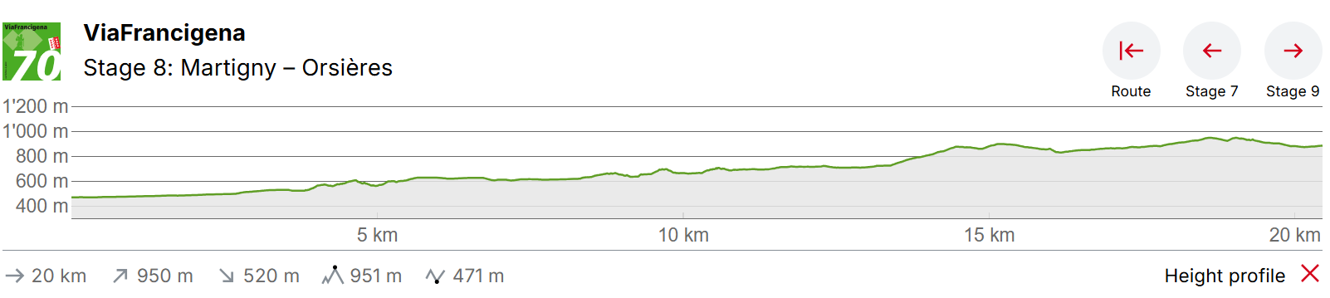

This stage marks the beginning of the ascent to the Great St. Bernard Pass. From Martigny, a path that is steep in parts leads across the narrow Les Trappistes Pass to the medieval village of Sembrancher. From there, the route follows the Napoleon Trail.
Martigny is a small town with southern panache and a cultural heritage from Celtic and Roman times. In addition to the 2,000-year history, the town on the Rhone bend is also well-known for its cuisine. Surrounded by vineyards and orchards, personalities such as Rousseau, Goethe, Stendhal and Liszt have been seduced by its culinary delights. The previous Swiss stages of the Via Francigena to Lake Geneva are fairly flat or downhill, but the section from Martigny marks the beginning of the ascent towards the Great St. Bernard Pass.
Once through the small town, you encounter the first upward part straight away from Martigny-Croix. The gravel road soon turns into a path. You cross the Dranse on a bridge and after about two hours you reach Les Valettes. You pass the Durnand Gorge. This is one of the most attractive gorges in Europe and offers a unique backdrop with its footbridges and steps made of wood, which tower over the fourteen waterfalls of the wild river.
The diverse path meanders through an enchanted coniferous forest past moss-covered stones, large rocks that can be climbed and mighty old tree roots. Once in Sembrancher, two thirds of the hike is complete. You leave the village through the medieval centre to go towards Orsières. The route alternates between paths, gravel tracks and a few asphalt roads as you approach the destination for this stage. Orsières is the centre of the Val Ferret tributary valley, and is characterised by the unspoilt heart of its village and a church with a bell tower from the 11th century.

Orsieres Accomodation
Gîte Accueil St-Bernard
10 places total – 15 CHF PPPN
A priori, les réservations pour 2027 devraient ouvrir la semaine prochaine.
Nous vous prions de visiter le site https://www.saint-bernard.ch/fr/sejourner/nos-hebergements/gite-accueil-st-bernard-5878 dès le 25 septembre.
Place de l'Eglise 1, 1937, Orsières, Switzerland

Hôtel Terminus | Café-Restaurant Quai de l’Ours
Oui bien sûr avec plaisir !
Nous avons 16 places en dortoirs et beaucoup de chambres si jamais. Les places en dortoir sont à 58 CHF/pers. avec le petit-déjeuner inclus.
Vous pourrez nous redire quand votre organisation le permet !
Route de la Gare 25
CH – 1937 Orsières
+41 27 552 11 00
